**Лабораторная работа №3 ИССЛЕДОВАНИЕ ИНТЕГРАЛЬНЫХ ПРЕОБРАЗОВАТЕЛЕЙ КОДОВ (ДЕШИФРАТОРА, ШИФРАТОРА) И КОММУТАЦИОННЫХ УЗЛОВ (ДЕМУЛЬТИПЛЕКСОРА И МУЛЬТИПЛЕКСОРА)**

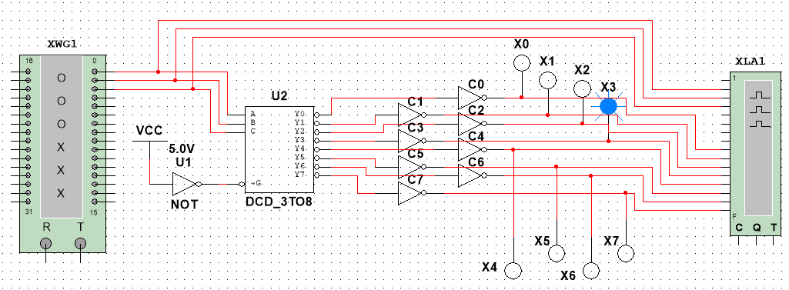**Задание 1**

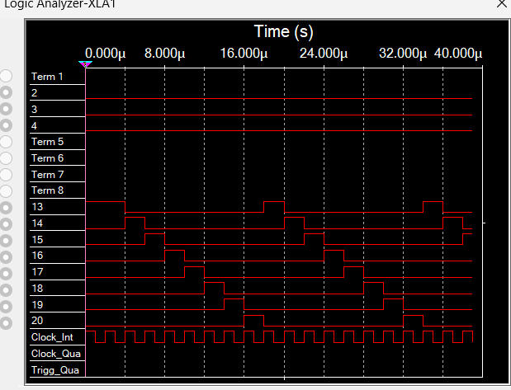

|  |  |  |  |  |  |  |  |  |
| --- | --- | --- | --- | --- | --- | --- | --- | --- |
| A | 0 | 1 | 0 | 1 | 0 | 1 | 0 | 1 |
| B | 0 | 0 | 1 | 1 | 0 | 0 | 1 | 1 |
| C | 0 | 0 | 0 | 0 | 1 | 1 | 1 | 1 |
| Y0 | 1 | 0 | 0 | 0 | 0 | 0 | 0 | 0 |
| Y1 | 0 | 1 | 0 | 0 | 0 | 0 | 0 | 0 |
| Y2 | 0 | 0 | 1 | 0 | 0 | 0 | 0 | 0 |
| Y3 | 0 | 0 | 0 | 1 | 0 | 0 | 0 | 0 |
| Y4 | 0 | 0 | 0 | 0 | 1 | 0 | 0 | 0 |
| Y5 | 0 | 0 | 0 | 0 | 0 | 1 | 0 | 0 |
| Y6 | 0 | 0 | 0 | 0 | 0 | 0 | 1 | 0 |
| Y7 | 0 | 0 | 0 | 0 | 0 | 0 | 0 | 1 |

**Задание 2**

|  |  |  |  |  |  |  |  |  |
| --- | --- | --- | --- | --- | --- | --- | --- | --- |
| A | 0 | 1 | 0 | 1 | 0 | 1 | 0 | 1 |
| B | 0 | 0 | 1 | 1 | 0 | 0 | 1 | 1 |
| C | 0 | 0 | 0 | 0 | 1 | 1 | 1 | 1 |
| Y0 | 1 | 0 | 0 | 0 | 0 | 0 | 0 | 0 |
| Y1 | 0 | 1 | 0 | 0 | 0 | 0 | 0 | 0 |
| Y2 | 0 | 0 | 1 | 0 | 0 | 0 | 0 | 0 |
| Y3 | 0 | 0 | 0 | 1 | 0 | 0 | 0 | 0 |
| Y4 | 0 | 0 | 0 | 0 | 1 | 0 | 0 | 0 |
| Y5 | 0 | 0 | 0 | 0 | 0 | 1 | 0 | 0 |
| Y6 | 0 | 0 | 0 | 0 | 0 | 0 | 1 | 0 |
| Y7 | 0 | 0 | 0 | 0 | 0 | 0 | 0 | 1 |
| A0 | 0 | 1 | 0 | 1 | 0 | 1 | 0 | 1 |
| A1 | 0 | 0 | 1 | 1 | 0 | 0 | 1 | 1 |
| A2 | 0 | 0 | 0 | 0 | 1 | 1 | 1 | 1 |

**Задание 3**



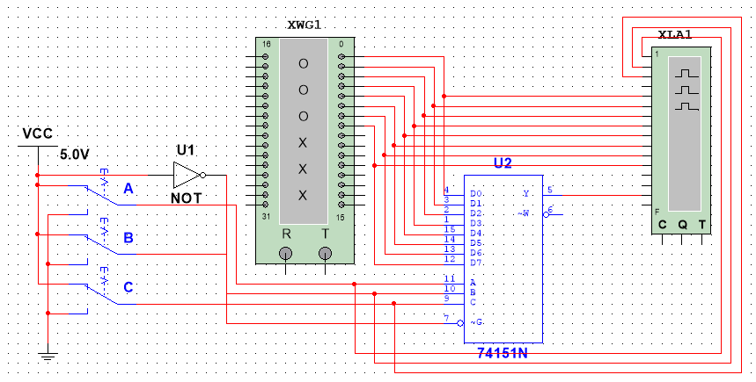**Задание 4**

**Задание 5**